Anantha Lakshmi Institute of Technology and Sciences (ALITS)
Department of Data Science

Visualizing Housing Market Trends: An Analysis of Sale Prices and Features using Tableau
Project Development Phase — Dashboard Screenshots Index

Project Name: Housing Market Trends using Tableau
Team ID: ALITS-DS-2026-HousingMarketTrends
Academic Year: 2026

Dashboard Screenshots — Actual Tableau Build
This folder contains screenshots captured directly from the completed Tableau workbook (Transformed Housing Data), showing each worksheet and the combined dashboard exactly as built.
File | Contents
Dashboard_1_Comprehensive_House_Price_Analysis.png | The full Dashboard 1 combining all four worksheets with the Age of House filter
Sheet_1_KPI_Summary.png | KPI table: Count of Transformed_Housing_Data (21,609), Sale Price (11,055,565,423), Area of the House from Basement (38,643,798)
Sheet_2_Sale_Price_Histogram.png | Total Sales by Years Since Renovation — Sale Price binned histogram
Sheet_3_House_Age_by_Renovation_Status.png | Distribution of House Age by Renovation Status — pie chart
Sheet_4_House_Age_by_Bathrooms_Bedrooms_Floors.png | House Age Distribution by Number of Bathrooms, Bedrooms, and Floors — grouped bar chart

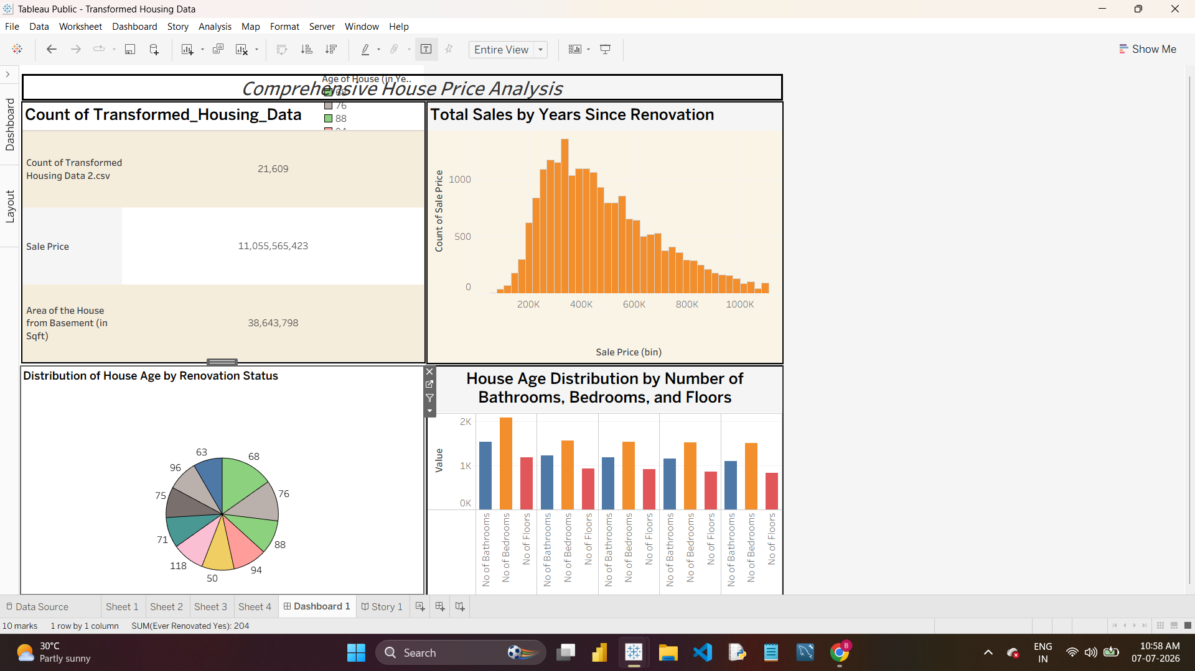
Dashboard 1 — Comprehensive House Price Analysis
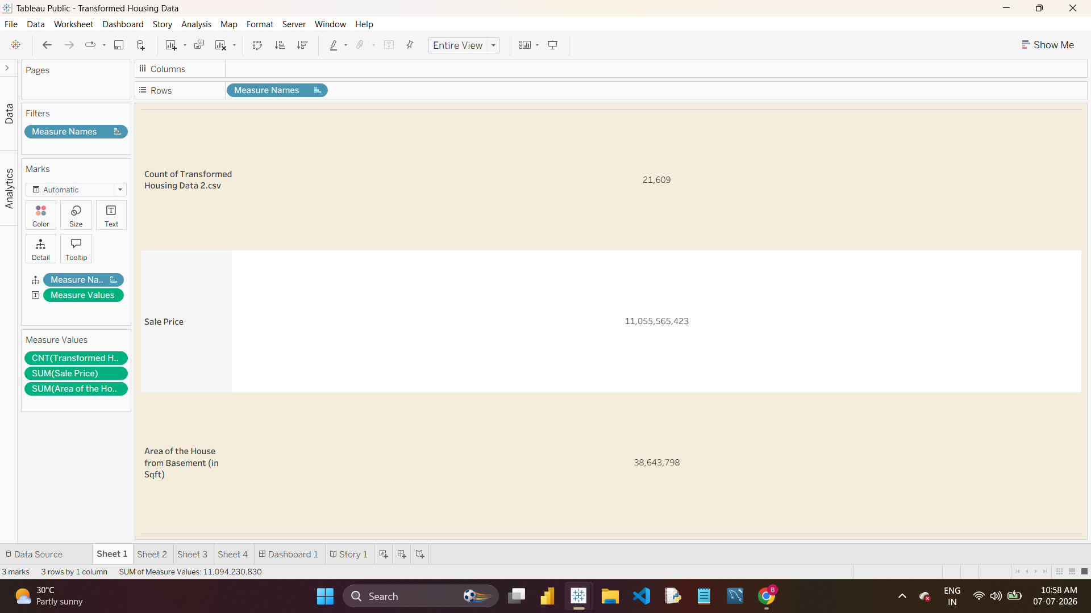
Sheet 1 — KPI Summary
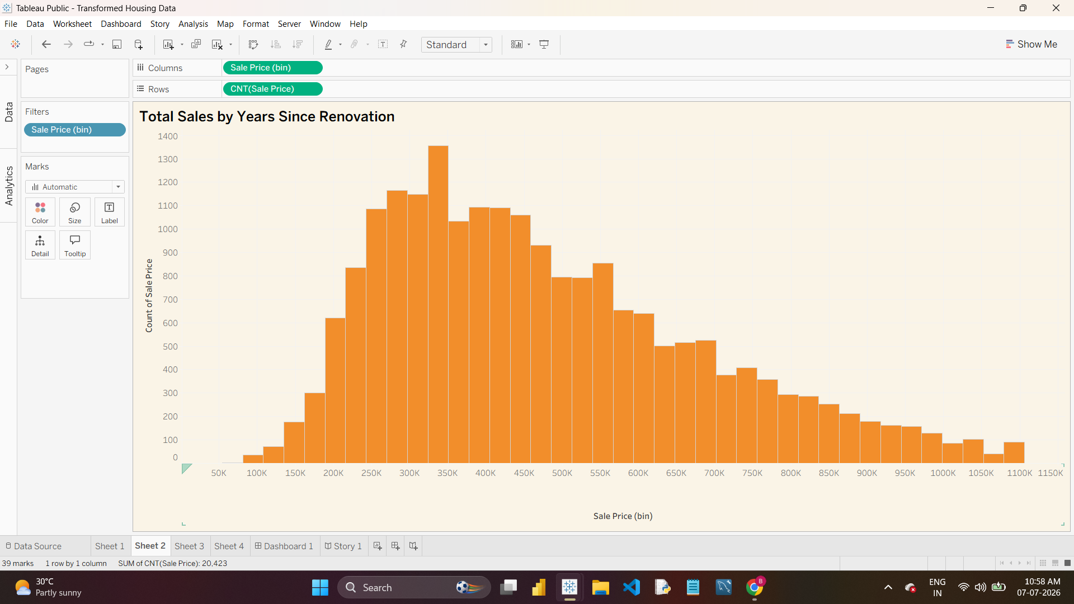
Sheet 2 — Sale Price Histogram
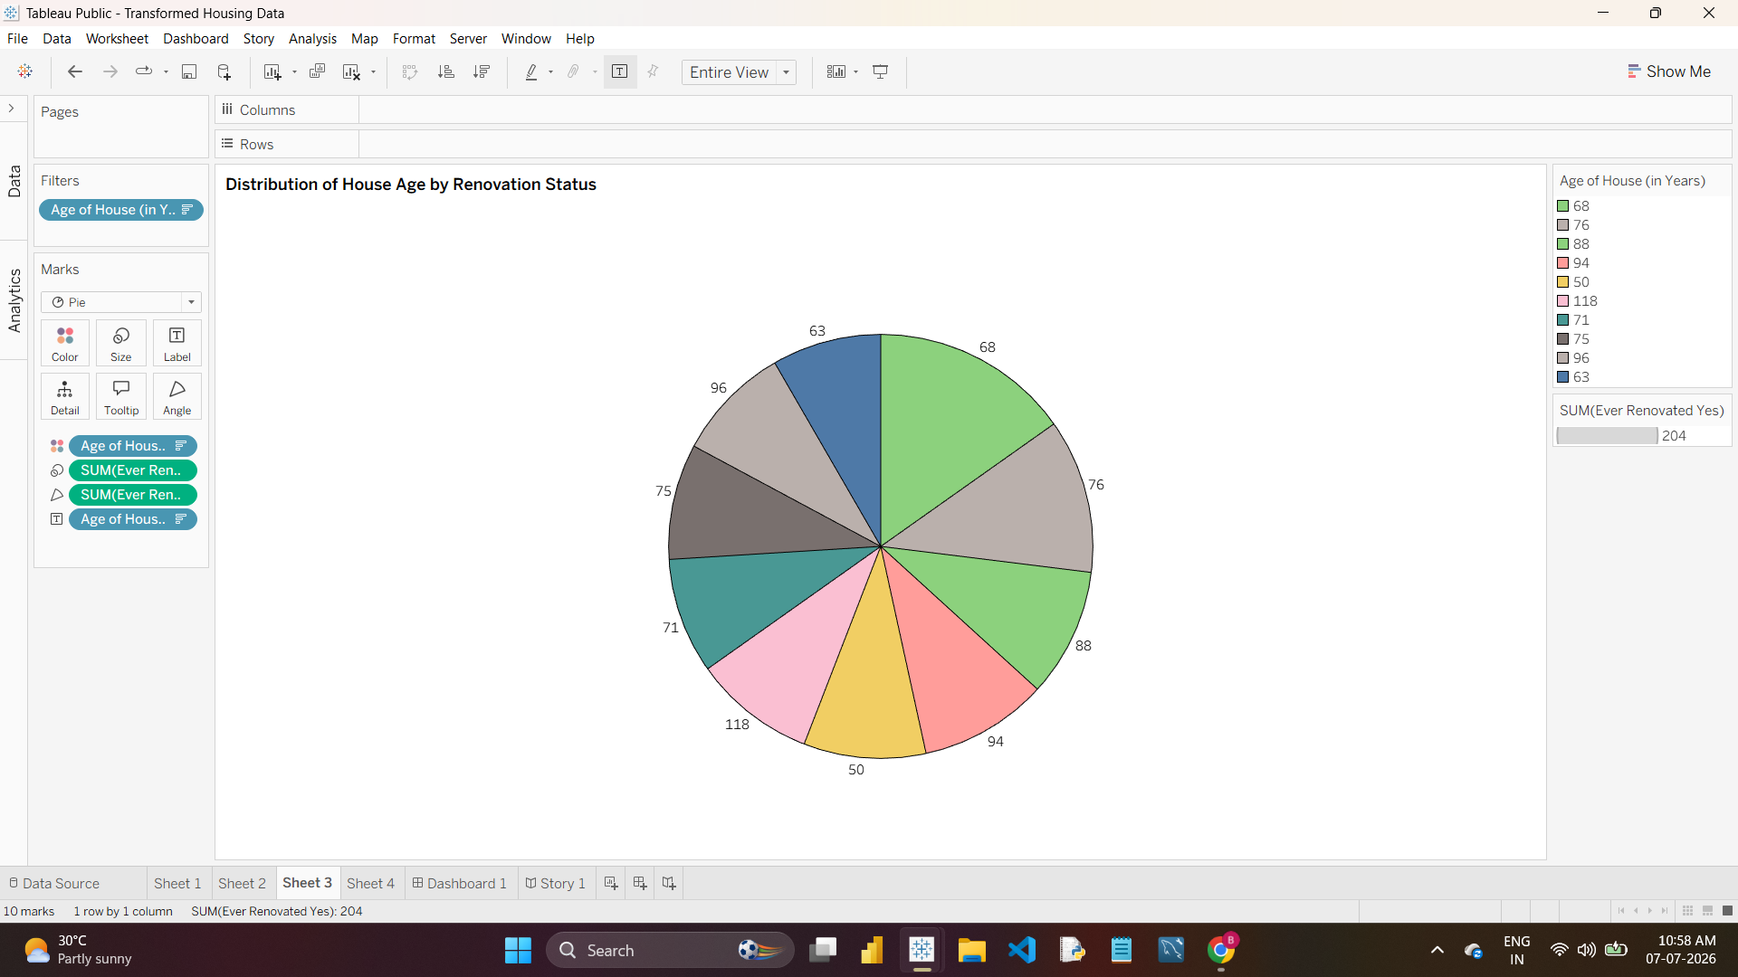
Sheet 3 — House Age by Renovation Status
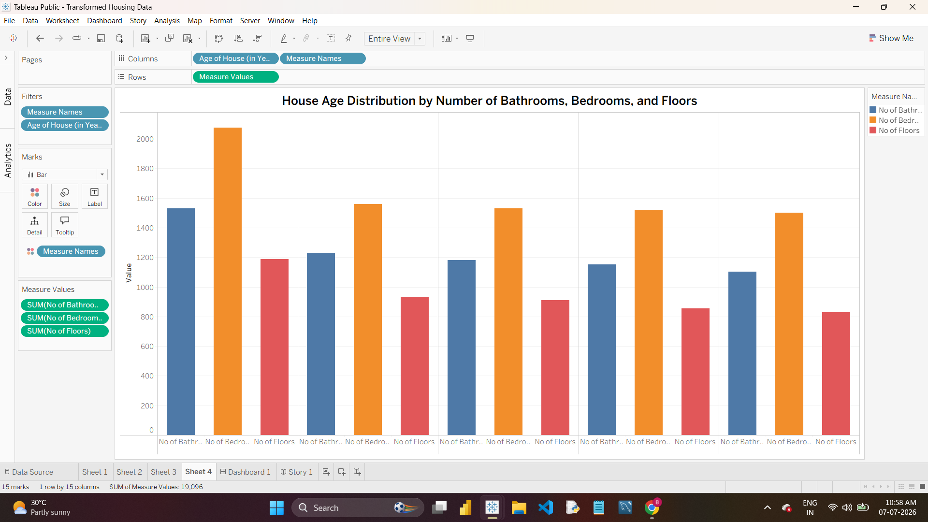
Sheet 4 — House Age by Bathrooms/Bedrooms/Floors

